Implementation of Water Jug Problem Using Python
Aim
To obtain the required amount of water using two water jugs of different capacities.
Objective
- To represent the water jug problem as a state-space problem.
- To perform filling, emptying, and transferring operations.
- To generate possible states of the jugs.
- To reach the target quantity of water.
- To find a valid solution path.
Algorithm
- Start with both jugs empty.
- Fill either jug completely.
- Empty either jug whenever required.
- Pour water from one jug to another until one jug becomes empty or the other becomes full.
- Generate all possible states after each operation.
- Check whether the target amount of water is obtained.
- If the target is reached, display the solution path.
- Otherwise, continue exploring new states.
- Stop when the target amount is found.

PYTHON CODE:
from collections import deque

def water_jug(jug1, jug2, target):
visited = set()
queue = deque([(0, 0)])

while queue:
x, y = queue.popleft()

if (x, y) in visited:
continue

visited.add((x, y))
print((x, y))

if x == target or y == target:
print("Target reached!")
return

next_states = [
(jug1, y),
(x, jug2),
(0, y),
(x, 0),
(max(0, x-(jug2-y)), min(jug2, y+x)),
(min(jug1, x+y), max(0, y-(jug1-x)))
]

for state in next_states:
if state not in visited:
queue.append(state)

water_jug(4, 3, 2)

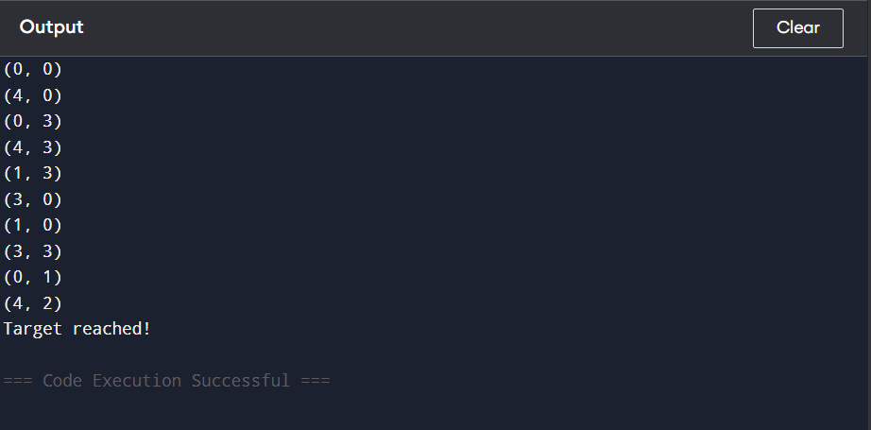
OUTPUT:

FLOW CHART:

Result
Thus, the Water Jug Problem was successfully solved and the target amount of water was obtained.

